You are given an m x n grid where each cell can have one of three values:

* 0 representing an empty cell,
* 1 representing a fresh orange, or
* 2 representing a rotten orange.

Every minute, any fresh orange that is **4-directionally adjacent** to a rotten orange becomes rotten.

Return *the minimum number of minutes that must elapse until no cell has a fresh orange*. If *this is impossible, return* -1.

**Example 1:**

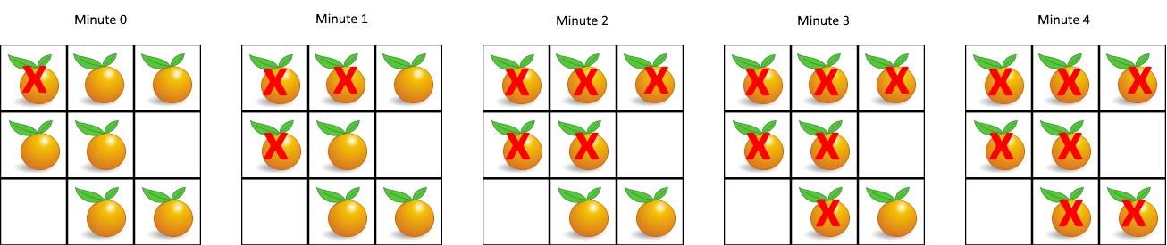

Input: grid = [[2,1,1],[1,1,0],[0,1,1]]  
Output: 4

**Example 2:**

Input: grid = [[2,1,1],[0,1,1],[1,0,1]]  
Output: -1  
Explanation: The orange in the bottom left corner (row 2, column 0) is never rotten, because rotting only happens 4-directionally.

**Example 3:**

Input: grid = [[0,2]]  
Output: 0  
Explanation: Since there are already no fresh oranges at minute 0, the answer is just 0.

**Constraints:**

* m == grid.length
* n == grid[i].length
* 1 <= m, n <= 10
* grid[i][j] is 0, 1, or 2.